**Lab Record**

**of**

***DOTNET Technologies***

***(CS 205)***



**Submitted to:Submitted by:**

*Sandhya Adhikari Harshit Awasthi*

*Assistant Professor 180178029*

*School of Computing (CSE) B.Tech(CSE-ML)*

*DIT University 2nd year(4th sem)*

**Session 2019-20**

Index

|  |  |  |  |
| --- | --- | --- | --- |
| **S.No** | **Title of Experiment/Objective** | **Date of Conduction** | **Signature of Faculty** |
| 1 | Write a C# program to understand the basic construct and implement simple interest calculation | 30-01-2020 |  |
| 2 | Write a C# program to calculate no. of 1’s in given number | 30-01-2020 |  |
| 3 | Write a C# Program to input 1-D array and apply the various methods of array class. | 06-02-2020 |  |
| 4 | Write a C# program to implement 2D array and jagged array. | 06-02-2020 |  |
| 5 | Write a C# Program to implement string and string builder with their methods . ( at least 3 methods each) | 05-03-2020 |  |
| 6 | Create a Windows form to calculate (sum, difference, product, division and remainder) | 28-03-2020 |  |
| 7 | Design a form in C# that takes the details of a person (Name, Address AND DOB) and enables Radio Button to vote if the age of the person is above 18 and then shows a Thanks message. | 28-03-2020 |  |
| 8 | Write a C# program to implement various types of parameters in a function. (Value, Reference, Output and parameter array) | 02-04-2020 |  |
| 9 | Create an ADO.NET application to connect with a Database and implement insert, update and delete commands. | 02-04-2020 |  |
| 10 | Create a registration form implementing different validation objects using ASP.NET. | 09-04-2020 |  |
| 11 |  |  |  |
| 12 |  |  |  |
| 13 |  |  |  |
| 14 |  |  |  |
| 15 |  |  |  |

# **Practical 1**

**OBJECTIVE**- Write a C# program to understand the basic construct and implement simple interest calculation

**PROGRAMME CODE :-**

using System;

using System.Collections.Generic;

using System.Linq;

using System.Text;

namespace simple_interst

{

class Program

{

static void Main(string[] args)

{

Console.WriteLine("Harshit Awasthi 180178029");

double p, r, t, si;

Console.Write("Enter the principal ammount: ");

p = Convert.ToDouble(Console.ReadLine ());

Console.Write("Enter the rate of interst: ");

r = Convert.ToDouble(Console.ReadLine());

Console.Write("Enter the time duration: ");

t = Convert.ToDouble(Console.ReadLine());

si = (p * r * t) / 100;

Console.WriteLine("Simple_Interst is: "+si);

}

}

}

# **OUTPUT :-**

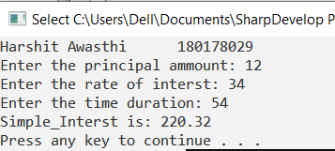

# **Practical 2**

**OBJECTIVE** – Write a C# program to calculate no. of 1’s in given number

**PROGRAM CODE :-**

using System;

using System.Collections.Generic;

using System.Linq;

using System.Text;

namespace Ones

{

class Program

{

static void Main(string[] args)

{

Console.WriteLine("Harshit Awasthi 180178029");

int no,count=0;

Console.Write("Enter a number: ");

no = Convert.ToInt32(Console.ReadLine());

while (no > 0)

{

if (no % 10 == 1)

count++;

no=no/10;

}

Console.WriteLine("No of ones are: "+count);

Console.ReadKey();

}

}

}

**OUTPUT :-**

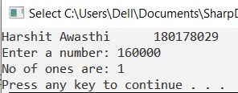

# **Practical 3**

**OBJECTIVE -** Write a C# Program to input 1-D array and apply the various methods of array class.

**PROGRAM CODE :-**

using System;

using System.Collections.Generic;

using System.Linq;

using System.Text;

namespace _1_D_array

{

class Program

{

static void Main(string[] args)

{

Console.WriteLine("Harshit Awasthi 180178029");

//taking input size of array

Console.Write("Enter the size of ARRAY: ");

int n = Convert.ToInt32(Console.ReadLine());

int[] ar = new int[n];

Console.WriteLine("Enter the elements of ARRAY: ");

for (int i = 0; i < n; i++)

{

ar[i] = Convert.ToInt32(Console.ReadLine());

}

//Printing Element

Console.Write("\nPrinting element() : ");

for (int i = 0; i<n; i++)

{

Console.Write(ar[i] + " ");

}

// Sorting

Console.Write("\nAfter Sort() : ");

Array.Sort(ar);

for (int i = 0; i < n; i++)

{

Console.Write(ar[i] + " ");

}

//Binary search

Console.Write("\n\nBinary Search()");

Console.Write("\nEnter the element you want to search: ");

int b = Convert.ToInt32(Console.ReadLine());

int a=Array.BinarySearch(ar,b);

if (a >= 0)

{

Console.WriteLine("Element found at location: " +(a+1));

}

else

{

Console.WriteLine("Element not found");

}

//Reverse

Array.Reverse(ar);

Console.Write("\nAfter Reverse() : ");

for (int i = 0; i < n; i++)

{

Console.Write(ar[i] + " ");

}

int[]arr= ar.Clone() as int[];

Console.Write("\nAfter cloning() : ");

for (int i = 0; i < n; i++)

{

Console.Write(+arr[i] + " ");

}

Console.ReadKey();

}

}

}

**OUTPUT :-**

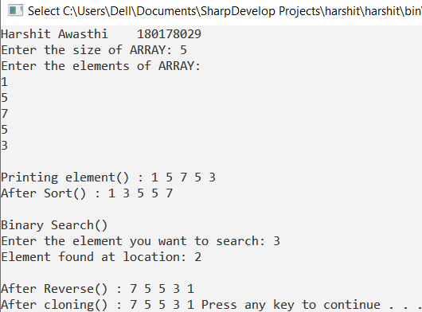

# **Practical 4**

**OBJECTIVE :** Write a C# program to implement 2D array and jagged array.

**PROGRAM CODE :-**

using System;

using System.Collections.Generic;

using System.Linq;

using System.Text;

namespace _2D_Array

{

class Program

{

static void Main(string[] args)

{

Console.WriteLine("Harshit Awasthi 180178029");

Console.Write("Enter the value of no of rows: ");

int row = Convert.ToInt32(Console.ReadLine());

Console.Write("Enter the value of no of columns: ");

int col = Convert.ToInt32(Console.ReadLine());

int[,] a = new int[row, col];

Console.WriteLine("Enter the elements of array");

for (int i = 0; i < row; i++)

{

for (int j = 0; j < col; j++)

{

a[i, j] = Convert.ToInt32(Console.ReadLine());

}

}

Console.WriteLine("Elements are:");

for (int i = 0; i < row; i++)

{

for (int j = 0; j < col; j++)

{

Console.Write(a[i, j] + " ");

}

Console.WriteLine();

}

Console.ReadKey();

Console.WriteLine("Jagged Array Program");

Console.Write("Enter the no of arrays: ");

int r = Convert.ToInt32(Console.ReadLine());

int[][] jagged = new int[r][];

for (int i = 0; i < r; i++)

{

Console.Write("Enter the size of array: ");

int c = Convert.ToInt32(Console.ReadLine());

jagged[i] = new int[c];

for (int j = 0; j < c; j++)

{

jagged[i][j] = Convert.ToInt32(Console.ReadLine());

}

}

Console.WriteLine("Elements are:");

for (int i = 0; i < r; i++)

{

for (int j = 0; j < jagged[i].Length; j++)

{

Console.Write(jagged[i][j] + " ");

}

Console.WriteLine();

}

Console.ReadKey();}}}

**OUTPUT:-**

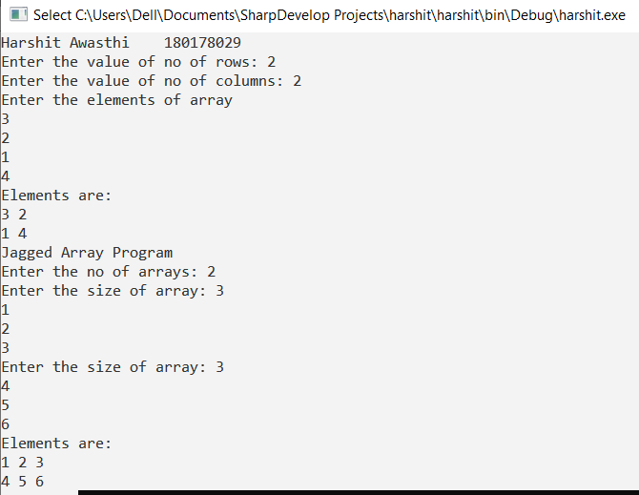

# **Practical 5**

**OBJECTIVE -** Write a C# Program to implement string and stringbuilder with their methods . (atleast 3 methods each)

**PROGRAM CODE:-**

**using** System;  
**using** System.Collections.Generic;  
**using** System.Linq;  
**using** System.Text;  
  
**namespace** Strings  
{  
    class Program  
    {  
        static void **Main**(string[] args)  
        {  
            Console.**Write**("Enter 1st string :");  
            String a = Console.**ReadLine**();  
            Console.**Write**("Enter 2nd string :");  
            String b = Console.**ReadLine**();  
            Console.**Write**("\nEnter the index of String 1 of  which you want to get character: ");  
            **int** n = Convert.**ToInt32**(Console.**ReadLine**());  
             **char** c = a.**ElementAt**(n) ;  
            Console.**WriteLine**("Element at "+n+"th index:"+c);  
            Console.**WriteLine**("\nLength of string 1: " + a.Length);  
            Console.**WriteLine**("\nLength of string 2: " + b.Length);  
            String d = String.**Concat**(a, b);  
            Console.**WriteLine**("\nNew String d after concatination: " +d);  
            String f = String.**Copy**(a);  
            Console.**WriteLine**("\nNew String f: " + f);  
            Console.**WriteLine**("\n\n");  
            StringBuilder sb = **new** **StringBuilder**(hello maliikarjun");  
            sb.**Append**(" nobody");  
            Console.**WriteLine**("\nStringbuilder sb after append :"+sb);  
            sb.**Replace**(", " chaplin");  
            Console.**WriteLine**("\nStringbuilder sb after replacement :" + sb);  
            sb.**Insert**(16, "bigger");  
            Console.**WriteLine**("\nStringbuilder sb after insertion :" + sb);  
            sb.**Remove**(14, 2);  
            Console.**WriteLine**("\nStringbuilder sb after removal:" + sb);  
           Console.**ReadLine**();  
              
        }  
    }  
}

**Output :-**

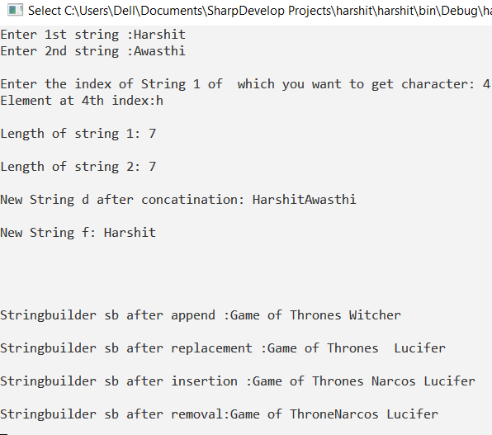

# **Practical 6**

**OBJECTIVE -** Create a Windows form to calculate (sum, difference, product, division and remainder)

**PROGRAM CODE:-**

using System;

using System.Collections.Generic;

using System.ComponentModel;

using System.Data;

using System.Drawing;

using System.Linq;

using System.Text;

using System.Threading.Tasks;

using System.Windows.Forms;

namespace WindowsFormsApp2

{

public partial class Form1 : Form

{

public Form1()

{

InitializeComponent();

}

private void button1_Click(object sender, EventArgs e)

{

float a = Convert.ToInt32(textBox1.Text);

float b = Convert.ToInt32(textBox2.Text);

float c = a + b;

float d = a - b;

float f = a * b;

float g = a / b;

float h = a % b;

label3.Text = "Sum = "+c.ToString();

label4.Text = "diff = " + d.ToString();

label5.Text = "mul = " + f.ToString();

label6.Text = "div = " + g.ToString();

label7.Text = "rem = " + h.ToString();

**OUTPUT:-**

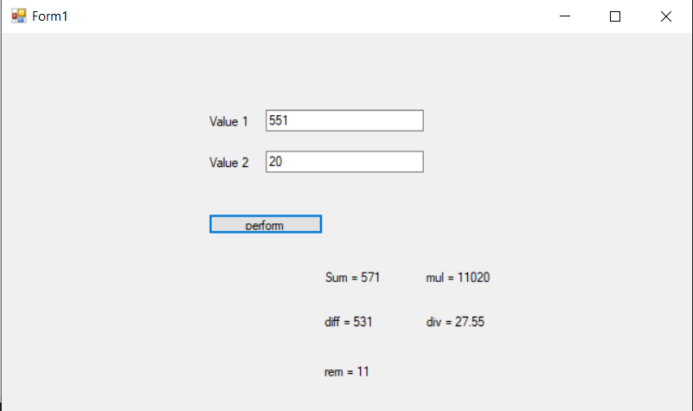

# **Practical 7**

**OBJECTIVE -** Design a form in C# that takes the details of a person (Name, Address AND DOB) and enables Radio Button to vote if the age of the person is above 18 and then shows a Thanks message.

**PROGRAM CODE:-**

using System;

using System.Collections.Generic;

using System.ComponentModel;

using System.Data;

using System.Drawing;

using System.Linq;

using System.Text;

using System.Threading.Tasks;

using System.Windows.Forms;

namespace abhinavgradedlab2april

{

public partial class Form2 : Form

{

public Form2()

{

InitializeComponent();

}

private void button1_Click(object sender, EventArgs e)

{

string Name = textBox1.Text;

string address = textBox2.Text;

DateTime startdate = dateTimePicker1.Value;

DateTime enddate = dateTimePicker2.Value;

long age = calcage(startdate, enddate);

long calcage(System.DateTime Startdate, System.DateTime EndDate)

{

System.TimeSpan ts = new TimeSpan(Startdate.Ticks - EndDate.Ticks);

age = (long)(ts.Days / 365);

return age;

}

if (age > 18)

{

radioButton1.Enabled = true;

}

else

{

MessageBox.Show("Sorry" + Name + " you are not eligible");

}

}

private void radioButton1_CheckedChanged(object sender, EventArgs e)

{

MessageBox.Show("Thanks " + textbox1.text + " for your valueable Vote");

}

}

}

**OUTPUT:-**

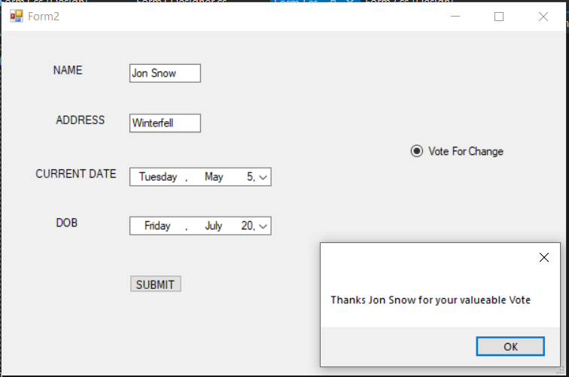

# **Practical 8**

**OBJECTIVE -** Write a C# program to implement various types of parameters in a function. (Value, Reference, Output and parameter array)

**PROGRAM CODE:-**

using System;

namespace METHODPARAMETERS

{

class Student

{

public int stu_age;

}

class Program

{

static void swap(int x , int y)

{

int temp = x;

x = y;

y = temp;

Console.WriteLine("Value of a in swap method: " + x);

Console.WriteLine("Value of b in swap method: " + y);

}

static void Square(Student x, Student y)

{

x.stu_age = x.stu_age * x.stu_age;

y.stu_age = y.stu_age * y.stu_age;

Console.WriteLine("x.stu_age in Square method : " + x.stu_age);

Console.WriteLine("y.stu_age in Square method: " + y.stu_age);

}

public void getValue(out int x)

{

Console.Write("Enter the value of temp: ");

int temp = Convert.ToInt32(Console.ReadLine());

x = temp*temp;

}

public int AddElements(params int[] arr)

{

int sum = 0;

foreach (int i in arr)

{

sum += i;

}

return sum;

}

static void Main(string[] args)

{

Console.WriteLine("HARSHIT AWASTHI 180178029");

Program p = new Program();

int a, b;

Console.Write("Enter the value of first number: ");

a = Convert.ToInt32(Console.ReadLine());

Console.Write("Enter the value of second number: ");

b = Convert.ToInt32(Console.ReadLine());

Console.WriteLine("Value of a before swap: " + a);

Console.WriteLine("Value of b before swap: " + b);

swap(a, b);

Console.WriteLine("Value of a after swap method: " + a);

Console.WriteLine("Value of b after swap method: " + b);

Student s1 = new Student();

Student s2 = new Student();

Console.Write("Enter the value of s1.stu_age: ");

s1.stu_age=Convert.ToInt32(Console.ReadLine());

Console.Write("Enter the value of s2.stu_age: ");

s2.stu_age=Convert.ToInt32( Console.ReadLine());

Console.WriteLine("\n\ns1.stu_age: " + s1.stu_age);

Console.WriteLine("s2.stu_age: " + s2.stu_age);

Square(s1, s2);

Console.WriteLine("s1.stu_age after Square method: " + s1.stu_age);

Console.WriteLine("s2.stu_age after Square method: " + s2.stu_age);

int n;

Console.Write("\n\nEnter the value of random variable n: ");

n = Convert.ToInt32(Console.ReadLine());

Console.WriteLine("Value of n before method call: " + n);

p.getValue(out n);

Console.WriteLine("After method call, value of n : "+ n);

Console.WriteLine("\n\n****PARAMETER ARRAY TYPE****");

int x;

Console.Write(" \n\nEnter the size of array: ");

x = Convert.ToInt32(Console.ReadLine());

int[] ar = new int[x];

for (int i = 0; i < x; i++)

{

Console.Write("Enter the " + i + "th element of array : ");

ar[i] = Convert.ToInt32(Console.ReadLine());

}

int sum = p.AddElements(ar);

Console.WriteLine("The sum is: "+sum);

}

}

}

**OUTPUT:-**

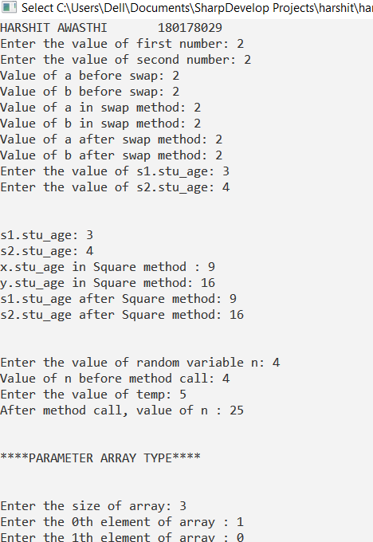

# **Practical 9**

**OBJECTIVE -** Create an ADO.NET application to connect with a Database and implement insert, update and delete commands.

**PROGRAM CODE:-**

**FORM 1**

using System;

using System.Collections.Generic;

using System.ComponentModel;

using System.Data;

using System.Drawing;

using System.Linq;

using System.Text;

using System.Threading.Tasks;

using System.Windows.Forms;

using System.Data.OleDb;

namespace MLDB2

{

public partial class Form1 : Form

{

private OleDbConnection connection = new OleDbConnection();

public Form1()

{

InitializeComponent();

connection.ConnectionString = @"Provider=Microsoft.ACE.OLEDB.12.0;Data Source=C:\Users\abhin\OneDrive\Documents\Database2.accdb";

}

private void Form1_Load(object sender, EventArgs e)

{

try

{

connection.Open();

label3.Text = "Connection Successfully established";

connection.Close();

}

catch (Exception ex)

{

MessageBox.Show(ex.Message);

}

}

private void button1_Click(object sender, EventArgs e)

{

connection.Open();

OleDbCommand command = new OleDbCommand();

command.Connection = connection;

command.CommandText = "select * from Datainfo where Name= '" + textBox1.Text + "'and Password='" + textBox2.Text + "'";

OleDbDataReader reader = command.ExecuteReader();

int count = 0;

while (reader.Read())

{

count++;

}

if (count == 1)

{

MessageBox.Show("Login Successful");

connection.Close();

connection.Dispose();

this.Hide();

Form2 f2 = new Form2();

f2.ShowDialog();

}

else if (count > 1)

{

MessageBox.Show("Duplicate data login can't be proceed");

connection.Close();

connection.Dispose();

this.Hide();

}

else

{

MessageBox.Show("Sorry invalid credential");

connection.Close();

connection.Dispose();

this.Hide();

}

connection.Close();

}

}

}

**FORM2**

using System;

using System.Collections.Generic;

using System.ComponentModel;

using System.Data;

using System.Drawing;

using System.Linq;

using System.Text;

using System.Threading.Tasks;

using System.Windows.Forms;

using System.Data.OleDb;

namespace MLDB2

{

public partial class Form2 : Form

{

OleDbConnection con = new OleDbConnection();

public Form2()

{

InitializeComponent();

con.ConnectionString = @"Provider=Microsoft.ACE.OLEDB.12.0;Data Source=C:\Users\abhin\OneDrive\Documents\Database2.accdb";

}

private void Form2_Load(object sender, EventArgs e)

{

try

{

con.Open();

OleDbCommand com = new OleDbCommand();

com.Connection = con;

com.CommandText = " select Rollno from Basicinfo";

OleDbDataReader reader = com.ExecuteReader();

while (reader.Read())

{

comboBox1.Items.Add(reader[0]);

listBox1.Items.Add(reader[0]);

}

con.Close();

}

catch (Exception ex)

{

MessageBox.Show(ex.Message);

}

finally

{

con.Close();

}

}

private void button1_Click(object sender, EventArgs e)

{

try

{

con.Open();

OleDbCommand com = new OleDbCommand();

com.Connection = con;

com.CommandText = "insert into BasicInfo values('" + textBox1.Text + "'," + textBox2.Text + ",'" + textBox3.Text + "')";

com.ExecuteNonQuery();

label4.Text = "DATA SAVED SUCCESSFULLY";

con.Close();

}

catch (Exception ex)

{

MessageBox.Show(ex.Message);

}

finally

{

con.Close();

}

}

private void button2_Click(object sender, EventArgs e)

{

try

{

con.Open();

OleDbCommand com = new OleDbCommand();

com.Connection = con;

com.CommandText = "update BasicInfo set [Name]='" + textBox1.Text + "', [Password]='" + textBox3.Text + "' where RollNO=" + textBox2.Text;

com.ExecuteNonQuery();

label4.Text = "DATA UPDATED SUCCESSFULLY";

con.Close();

}

catch (Exception ex)

{

MessageBox.Show(ex.Message);

}

finally

{

con.Close();

}

}

private void button3_Click(object sender, EventArgs e)

{

try

{

con.Open();

OleDbCommand com = new OleDbCommand();

com.Connection = con;

com.CommandText = "delete from BasicInfo where RollNO=" + textBox2.Text + "";

com.ExecuteNonQuery();

label4.Text = "DATA DELETED SUCCESSFULLY";

con.Close();

}

catch (Exception ex)

{

MessageBox.Show(ex.Message);

}

finally

{

con.Close();

}

}

private void comboBox1_SelectedIndexChanged(object sender, EventArgs e)

{

try

{

con.Open();

OleDbCommand com = new OleDbCommand();

com.Connection = con;

com.CommandText = "select Name,RollNO from BasicInfo where RollNO=" + comboBox1.Text + "";

OleDbDataReader reader = com.ExecuteReader();

while (reader.Read())

{

textBox1.Text = reader["Name"].ToString();

textBox2.Text = reader["RollNO"].ToString();

con.Close();

}

catch (Exception ex)

{

MessageBox.Show(ex.Message);

}

finally

{

con.Close();

}

}

private void listBox1_SelectedIndexChanged(object sender, EventArgs e)

{

try

{

con.Open();

OleDbCommand com = new OleDbCommand();

com.Connection = con;

com.CommandText = "select Name,RollNO from BasicInfo where RollNO=" + listBox1.Text + "";

OleDbDataReader reader = com.ExecuteReader();

while (reader.Read())

{

textBox1.Text = reader["Name"].ToString();

textBox2.Text = reader["RollNO"].ToString();

}

con.Close();

}

catch (Exception ex)

{

MessageBox.Show(ex.Message);

}

finally

{

con.Close();

}

}

private void button4_Click(object sender, EventArgs e)

{

try

{

con.Open();

OleDbCommand com = new OleDbCommand();

com.Connection = con;

com.CommandText = "select Name,RollNO from BasicInfo ";

OleDbDataAdapter da = new OleDbDataAdapter(com);

DataTable dt = new DataTable();

da.Fill(dt);

dataGridView1.DataSource = dt;

con.Close();

}

catch (Exception ex)

{

MessageBox.Show(ex.Message);

}

finally

{

con.Close();

}

}

private void dataGridView1_SelectionChanged(object sender, EventArgs e)

{

DataGridViewCell cell = null;

foreach (DataGridViewCell selectedcell in dataGridView1.SelectedCells)

{

cell = selectedcell;

break;

}

if(cell!=null)

{

DataGridViewRow row = cell.OwningRow;

textBox1.Text = row.Cells[0].Value.ToString();

textBox2.Text = row.Cells[1].Value.ToString();

}

}

}

}

**OUTPUT:-**

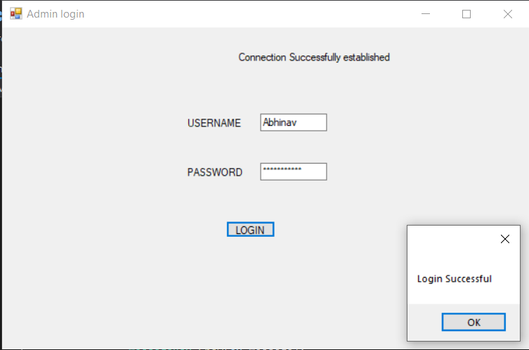

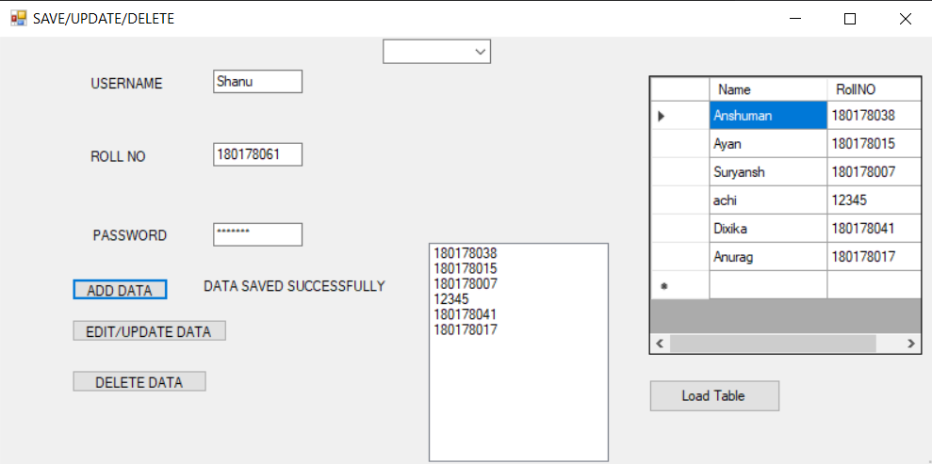

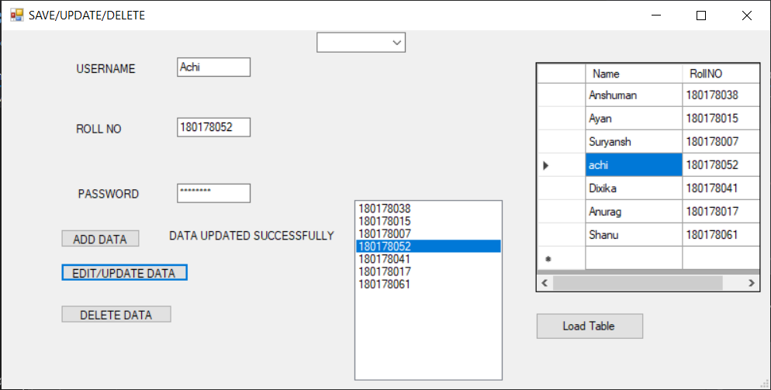

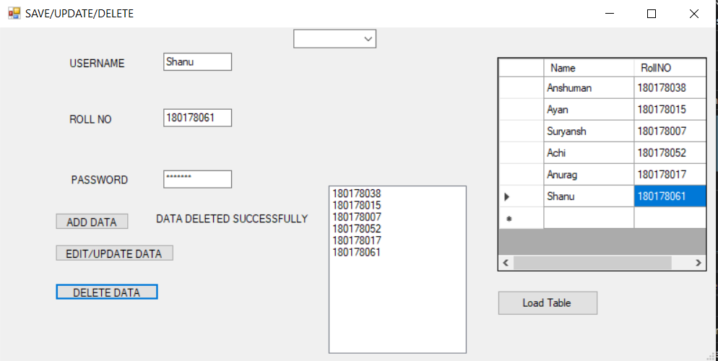

# **Practical 10**

**OBJECTIVE -** Create a registration form implementing different validation objects using ASP.NET.

**PROGRAM CODE:-**

using System;

using System.Collections.Generic;

using System.Linq;

using System.Web;

using System.Web.UI;

using System.Web.UI.WebControls;

namespace Webappasp

{

public partial class Registration : System.Web.UI.Page

{

protected void Page_Load(object sender, EventArgs e)

{

}

protected void Button2_Click(object sender, EventArgs e)

{

Response.Write("Registration successful");

}

**DESIGN:-**

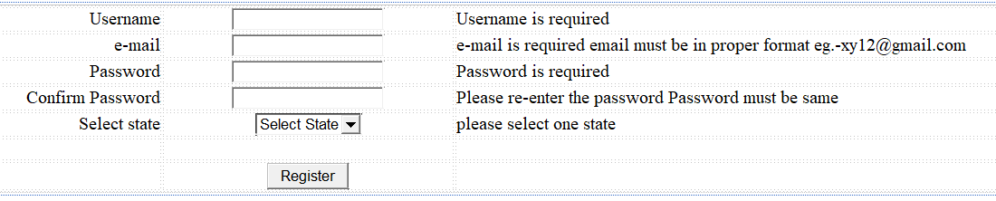

**OUTPUT:-**

